In this lab a network was made by connecting PC Nic-A (PC-A) to Switch 1 (S1), S1 to Router 1 (R1), and R1 to PC-B.
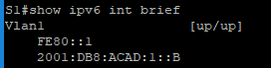
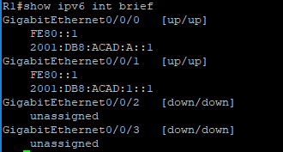
IPv6 addresses were then configured on each device and relevant port.
Addresses assigned to S1 and R1 can be seen above while address 2001:db8:acad:1::3 was assigned to PC-A and 2001:db8:acad:a::3 was assigned to PC-B.

While testing connectivity a couple issues were encountered that could not be resolved. S1 could not be pinged from PC-A. Connectivity from PC-B was not tested due to lacking time, but PC-A could ping both R1 and PC-B which was would require going through S1. It is assumed that some configuration or setting within S1 was limiting which traffic could directly interact with it while it’s basic functionality was still operational. See ping results below.
